Bellagio Appendix

‘New Faces’ Conference, Bellagio, Italy, July 1984,
sponsored by the Arms Control Association (USA)
and the International Institute for Strategic Studies (UK)

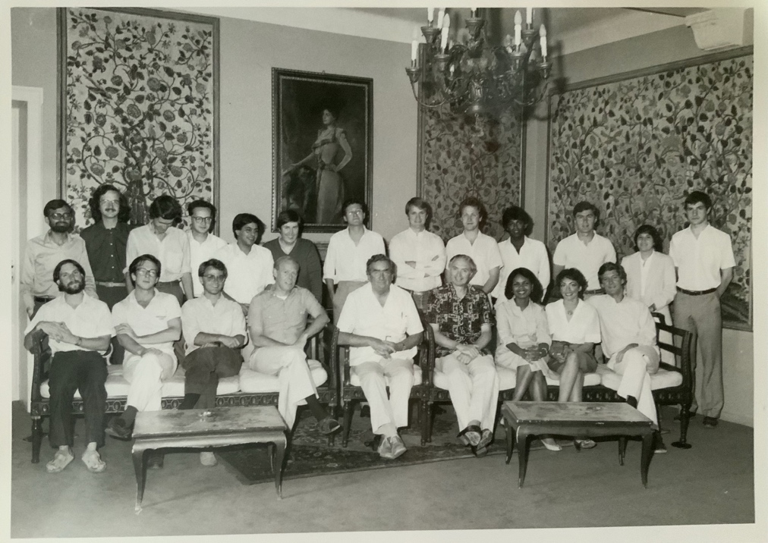

The photo is available online here.

Participants (with links to their later selves) included: Brahma Chellaney, John Chipman, Cathryn Downes, Matthew Evangelista, René Haug, Denis Healey, William Kincade, Dennis Kloske (see also here), Mark Kramer, Thomas Longstreth, Robert O’Neill, Condoleezza Rice, Thomas Risse (second from left in back row), Cynthia Roberts, Philip Sabin, Ali Tauqeer Sheikh, Marisol Touraine, Matthijs Van Bonzel

